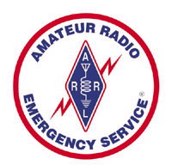
Each year hundreds of thousands of Americans volunteer their time and energies for the improvement and safety of their communities. Mechanics turn into firemen when the alarm sounds. Hairdressers become EMT's . Engineers turn into auxiliary policemen.
America has a long and proud history of these "Minutemen" who answer the call to service in times of emergency....
…and in Connecticut over 500 of them are “Hams!”
The Amateur Radio Emergency Service is a national, voluntary organization of FCC licensed Hams (shortwave) radio operators who provide emergency. communications in an emergency. Organized through the American Radio Relay League. This group has provided emergency communications services for everything from shipwrecks to the disaster of 9-11. It is a specialized field requiring training and federal licensing.

- ARES’ Skywarm program provides critical ground observations to the National Weather Services.

- The National Traffic Service has provided long distance emergency communication and free
radiograms for families for decades.

- The Red Cross uses ARES to provide emergency communications in a disaster. So does the
Salvation Army, OEM, FEMA, and hundreds of county and municipal governments.

When the World Trade Center was destroyed and cell phones were useless, who provided critical communications? ARES When an ice storm knocked out power and communications to thousands of people in Northwest Connecticut, who was on the scene allowing different agencies to talk to one another when other systems failed? ARES

Because each radio station operator is independent but still can talk to each other, it works….
• Even when the phones are down
• When there is no fax machine
• The internet is gone You can learn more about the ARRL and ARES at:
• The “trunk line” is jammed www.arrl.org www.CTAres.org
And the cell phone is dead

ARES is not another club—it is a service. While some clubs are affiliated with ARES, appointments are made through the section management and active members are expected to participate in continued training, education and events. There is a command structure with formal plans for action. We are especially looking for people who can form teams and go to a disaster site in a crisis and set up mobile communications.

TO JOIN OR UPDATE YOUR INFORMATION
The form on the other side of this paper is used for both initial application and annual updates.
Members MUST update their contact information annually. (You are of no use if we can’t contact you in an emergency!) Fill out the form and give it to your local EC or DEC.

Contacts in INSERT YOUR CLUB NAME HERE are:

Name_______call______ Name___________call_______ Name_________call_____

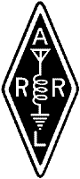
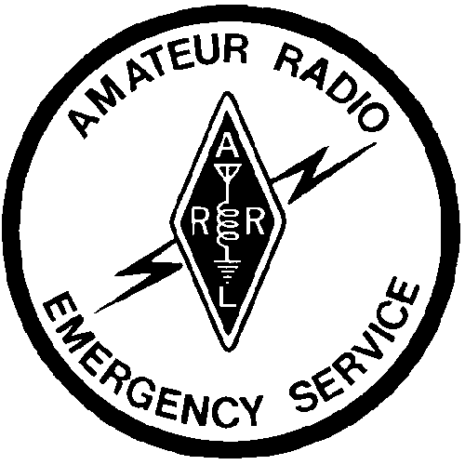
Name:_______________________________________________Call:_____________________

CT AMATEUR RADIO EMERGENCY SERVICE

Initial Application and Annual Update Form

Address:______________________________City:________________________________
State:___________________Zip:_________________ County_______________________
Home Phone:________________Work Phone:__________________Cell:_______________
E-mail Address:_________________________________Pager:_______________________
License Class:___________Primary Radio Interest:_________________________________
IF OPERATING PACKET, THE CALLSIGN OF YOUR HOME PBBS IS: ___________________________

Indicate bands/modes you can operate: H = Home, M = Mobile, P = Portable, A = All Three

 | 160 | 80/75 | 40 | 30 | 20 | 17 | 15 | 12 | 10 | 6 | 2 | 220 | 440 | Other
CW
FM
RTTY
SSB
PACKET
PSK-31
OTHER DIGITAL

Can your home station operate without commercial power [ ] Yes [ ] No
If yes, what bands ? ____________________________________________________________

ARRL EMCOMM CLASSES COMPLETED [ ] LEVEL 1 [ ] LEVEL 2 [ ] LEVEL 3
OTHER Emergency Communications Training in the past year _______________________________________

Activities in the past year _____________________________________________________________________

Signed:___________________________________________Date:_______________________

Signature of your EC or DEC or STM __________________________________________________________
Registration is for one year.

ACTIVE members are required to participate in 1 training and/or 1 event or ARES meeting per year.
(Simply checking into a net does not count as participation in an event for this purpose)
RESERVE members are encouraged, but not required, to have continuing education or participate in events/meetings.

All registrations should be returned to and signed by the EC or DEC for your locality or unit or the STM. The EC, DEC or STM will verify and send copy to SEC for inclusion in the database listings. Listings can be seen at www.CTares.org website

