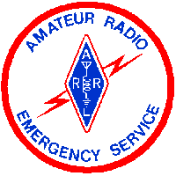
Handbook
For
Connecticut
Office of Emergency Management



Chuck Rexroad
AB1CR
Official Emergency Station
Connecticut Section
October 10, 2003

Table of Contents

Introduction 3
Purpose of OEM Station 3
Operations 3
Getting to Office of Emergency Management 3
Station Layout 5
Desktop Station 6
HF Radio 6
Dual-Band Radio (2 meters and 440) 6
PC 6
Workbench Station 7
Yaesu 2 meter Rig 7
Alinco packet radio, PK-232 TNC, and PC 8
Antenna Details 9
Power Supply Details 9
Radio Details 10
Reference Information (Frequencies, Call-Signs, etc.) 10

Introduction
This document was written to serve two purposes: (a) to provide a handbook for operators of the Amateur Radio equipment at OEM, and (b) to document the current equipment and its current condition.

Purpose of OEM Station
The ARES station at OEM is meant to be an interface between the State of Connecticut Office of Emergency Management (OEM) and other agencies that are relying on ARES communications. The OEM station is not meant to serve as a net control station, but rather as a net participant, albeit a very important one.

Operations
It is important to keep in mind that all ARES emergency nets are directed nets and that the Net Control Station is the person responsible for message flow. The OEM station may sit idle for long periods of time waiting for traffic. This is normal and while it may be frustrating it does not diminish the need for this station. The OEM station should check-in when it comes on the air, answer any roll calls from net control, and otherwise standby unless called by net control.

OEM is a net participant and needs to interact with the net just as any other participant would, with judicious use of words like priority or emergency. Just because the message originates from OEM does not mean it is a priority message. The message content determines the priority.

It is also important that in spite of all of the activity and noise that take place at OEM, the OEM station respond quickly when called by Net Control. There may be critical messages that need passed at any time. There are not currently headphones at OEM so operators would be will served to bring their own.

It should be noted that as of this date there is only one working 2-meter antenna available to be used. There is sufficient radio equipment to take full advantage of all of the working antennas, but should someone want to bring their own equipment there are two Anderson PowerPole connectors available to power it as shown in the Power Supply section of this document.

Getting to Office of Emergency Management
The Office of Emergency Management is located in the Armory building (see picture on title page) at 360 Broad St, Hartford, CT 06105. The phone number for the OEM Communications Team is 860-860-566-4737 and our main contact is Tom Walsh.

From 84 West, Take Exit 48 toward Asylum St. Go straight up ramp onto Spring St. Turn somewhat Right onto Asylum Ave and the turn left onto Broad St. The best parking is the parking garage beside the Armory.

CAUTION: Be prepared to show government issued ID, such as a drivers license, and to go through a metal detector while whatever you carry in will be hand checked by security.

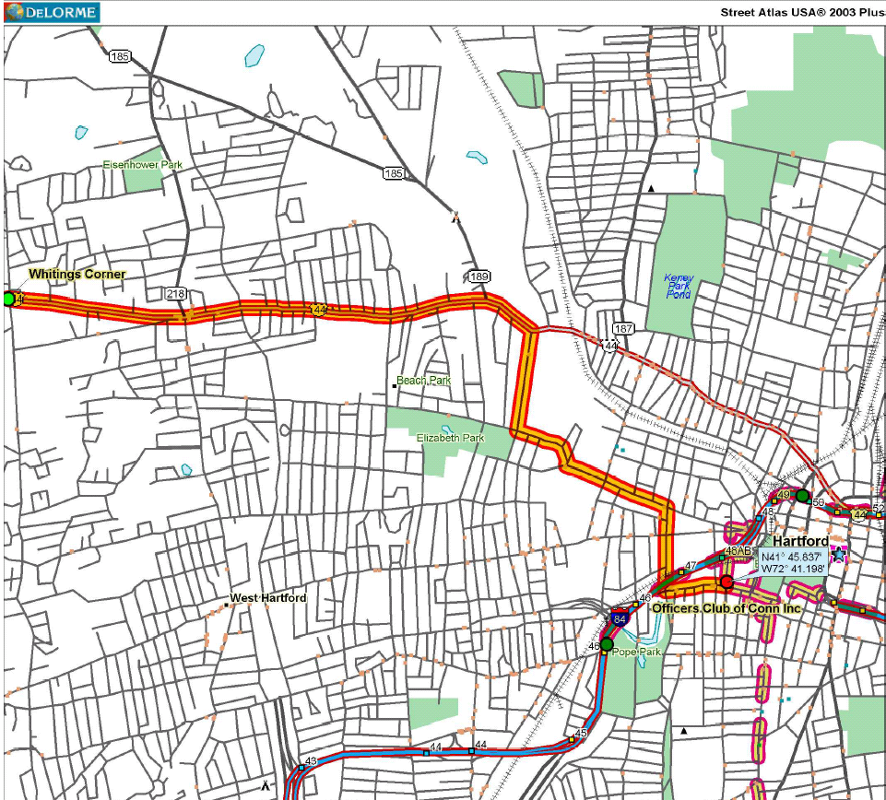
Thanks to Mac Harper for the map above

Station Layout

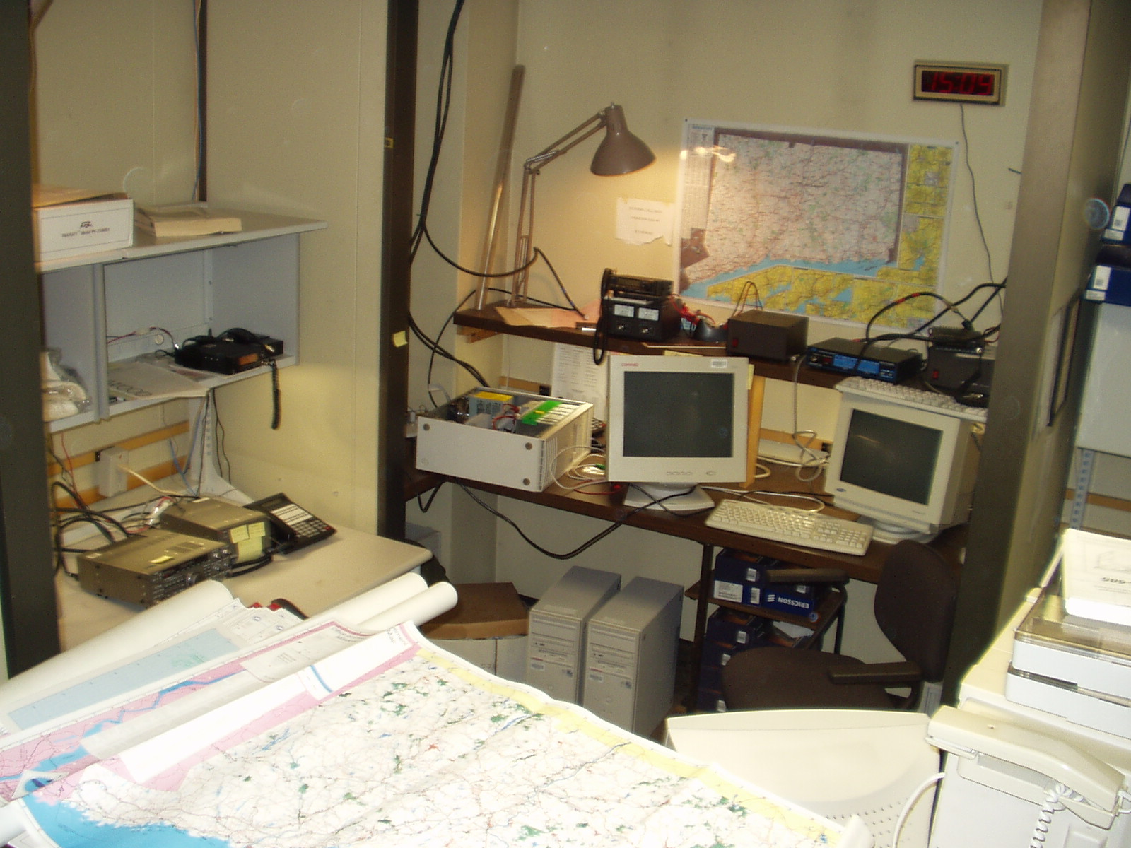

The overall station layout is shown above. The station is in the back of the OEM office and is a rather crowded area, surrounded by other radio systems (Police, FEMA, etc.). The station is in an L configuration with one portion of the L being a desk and the other being a workbench height area. This station will be very crowded if there are more than two operators, and there is not much room at OEM for additional operators to “hang around” so proper scheduling is necessary. (A total of three people at any time is probably a good idea in a major event, so that people can trade-off for a snack, restroom break, etc.)

NOTE: At the time these pictures were taken OEM was in the middle of a PC upgrade. The area will not usually be full of PCs and monitors.

Desktop Station
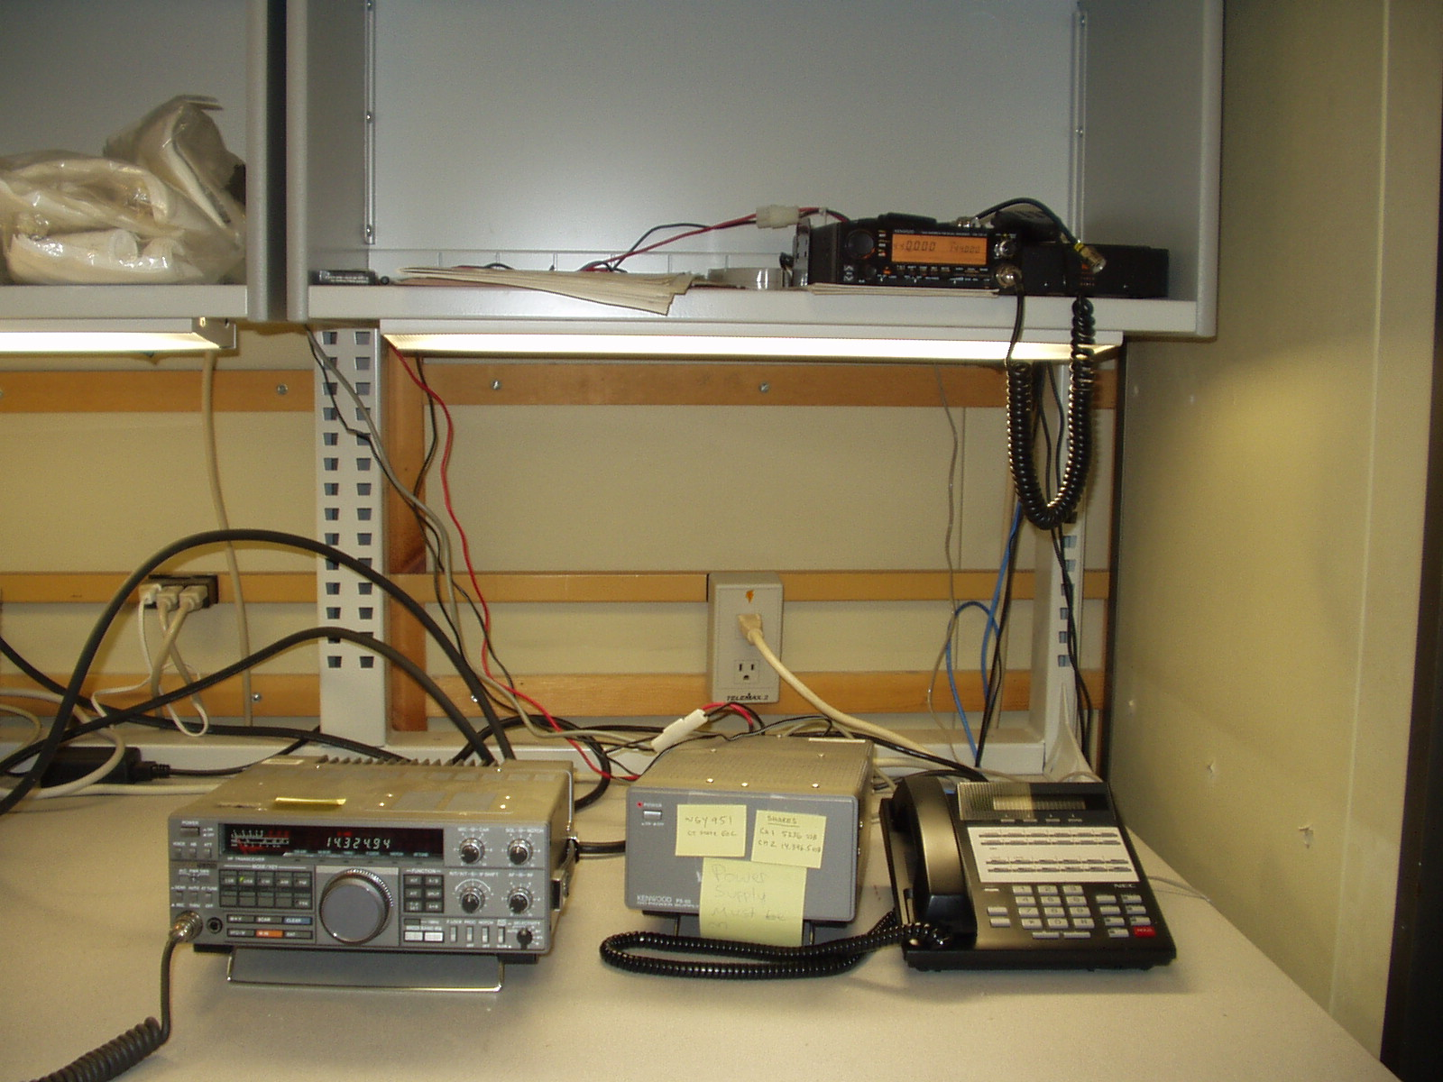

The desktop station facilities are shown above. The Power supply next to the HF rig powers the HF rig and the dual band (2 meters and 440) rig. This means that care should be taken not to transmit on both radios at the same time.

HF Radio
The HF rig should be connected to a piece of coax with no bands of tape on it (the tape marking system is based on bands of colored tape near the connector). This coax is connected to a Barker and Williamson folded dipole that provides excellent resonance in the major ham bands (see chart later in this document.) The HF rig has a built-in antenna tuner whose operation is unusual. The manual for the HF rig is on the shelf above it, along with the manual for the dual-band rig.

Dual-Band Radio (2 meters and 440)
The dual band radio does not have an antenna connected to it. An antenna can be selected for use with this radio based on the antenna information contained later in this document. The manual for the dual-band radio is underneath the radio.

PC
There is a rather old PC located in this area of the station. It does not serve any particular purpose at this time, but it does seem to have some old Civil Air Patrol software on it.

Workbench Station
The workbench station consists of two primary operating locations, the Yaesu 2 meter rig and the packet station.
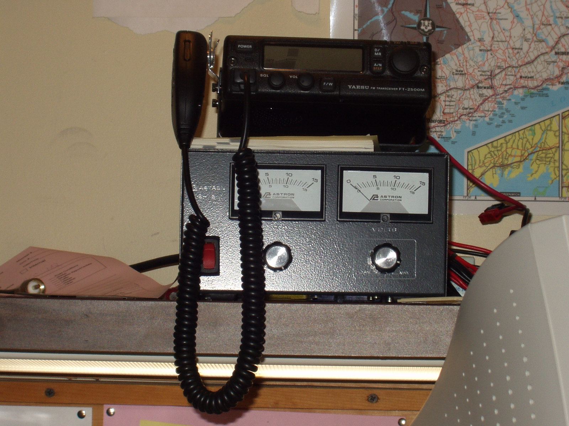

Yaesu 2 meter Rig
The Yaesu 2 meter rig is powered by the power supply that sits under it. Note that the right front of the radio has a flip-down panel that allows access to critical functions, even though the radio is pre-programmed(with Alpha-numeric tags) for most repeaters. The manual for the radio is next to the radio. No antenna is currently connected to this radio.

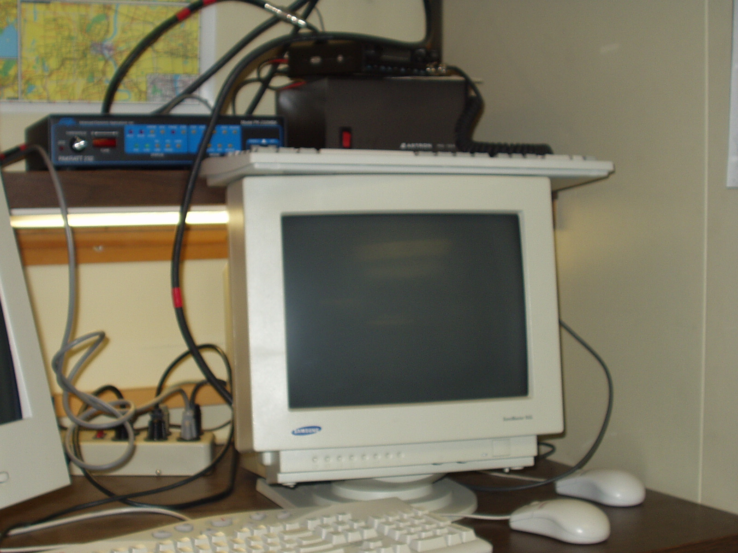

Alinco packet radio, PK-232 TNC, and PC
The Alinco radio, PK-232 TNC and PC make up a packet user station, not a node or BBS. It is up to the operator to select the most appropriate frequency, call-sign, etc. for using this station. The PC is setup to automatically boot to DOS and start the DOS based PK-232 software. Documentation on the PK-232 and its software is in the PK-232 box located at the desktop station. (Normally the packet rig would be expected to connect to W1EDH on 145.01 and through there to whatever BBS or other stations are desired. The PK-232 is configured with the callsign AB1CR which may be changed as appropriate, or left alone if the user is unfamiliar with how to change it.) There is currently no printer for the packet station, but the OEM computer upgrades that are in process may free up a printer for this station. There is currently no antenna connected to this radio.

Antenna Details
There is one functional HF antenna that seems to cover all bands, one 2-meter antenna that is working and two 44o antennas that are working. There is also one 6 meter antenna that is working. Antennas listed in red color below should not be used as they may damage the radio equipment.

Tape near the coax connector is labeling system. Color of tape denotes location on tower, but they are all pretty near the top so it is largely irrelevant

HF – No Stripe – Barker and Williamson Folded Dipole (Model BWDS-90)
50 MHz – One Stripe
144 MHz – two stripes
440 MHz – three stripes

HF Dipole Specifications
Band | Band Low | SWR Low | Band High | SWR High | Min SWR | Freq
80 | 3750 | 1.5 | 4000 | 1.5 | 1.2 | 3164
40 | 7150 | 2.3 | 7300 | 2.3 | 1.2 | 10000
20 | 14150 | 1.1 | 14350 | 1.2 | 1.1 | 14000
15 | 21200 | 1.6 | 21450 | 1.5 | 1.2 | 23400
10 | 28300 | 1.2 | 28700 | 1.4 | 1.2 | 28300

Other Antennas – Based on number of bands of colored tape on cable
1 blue | 50 | 5 | 54 | 5 |  | 9 on 52
2 blue | 144 | Too high to read |  | Too High to read
3 blue | 430 | 1.3 | 450 | 2 | 1.2 on 440
1 red | 50 | 2.2 | 54 | 2.5 | 1.3 | 52
2 red | 144 | 1.5 | 148 | 1.5
3 red | 430 | 2 | 450 | 2 | 1.3 | 445

Power Supply Details
Kenwood PS – 50 (13.4 volts at no load) powers Kenwood TS-440S and Kenwood TM-731 144/440 rig

Astron VS-12M(13.2 at no load) powers Yaesu FT-2500 M and has an open PowerPole connection

Astron RS-12A (13.9 volts no load) powers Alinco DR-110 2 meter rig for packet and AEAPK-232

Astron 10 Amp supply (14.3 Volts – no load) with no front panel designator powers open PowerPole connection

Radio Details
Kenwood TM-731A | 146.52 |  | 443 |  | Manual is under radio |  | No antenna connected | 144 MHz 50 watts - 430 35 watts specified not measured 430
Yaesu FT-2500M | rated 50/25/5 not measured |  |  |  | Manual is under radio |  | Connects to 2 blue bands
Alinco DR-119 | 145.06 | 50 watts | 5 watts measured |  | Manual is under radio |  | Connects to 2 red bands | 45 watts rated
Kenwood TS-440S | Manual is on shelf over radio |  |  |  |  |  | Connects to coax with no tape bands

Reference Information (Frequencies, Call-Signs, etc.)

WGY951 CT State EOC
Shares Channel 1 - 5236 USB
Shares Channel 2 - 14.396.5 USB

7.635.00 CAP National Headquarters

KB1BSQ is ham radio callsign for Ct Office of Emergency Management
NNN0OWN is MARS Callsign

